**Machine Learning Project**

**Title: Book Recommendation System**

**By -Diya 21csu304**

**Bhagyashri 21csu313**

**Introduction**

**In this project, we aimed to develop a book recommendation system utilizing collaborative filtering and popularity-based approaches. The system leverages user ratings and book metadata to suggest personalized recommendations to users based on their preferences and past interactions.**

**Data Overview**

**We utilized three datasets for our analysis:**

* **Books Dataset: Contains information about books including title, author, and ISBN.**
* **Ratings Dataset: Includes user ratings for different books.**
* **Users Dataset: Provides demographic information about users such as age and location.**

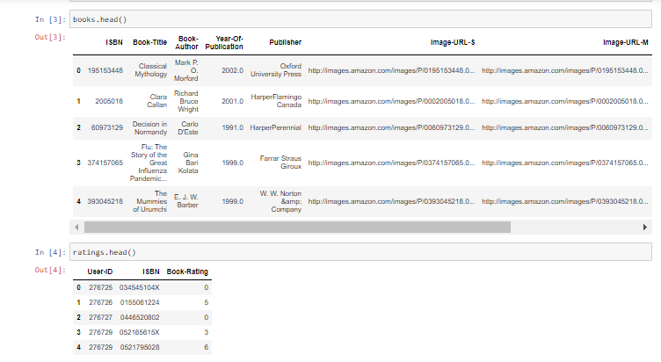

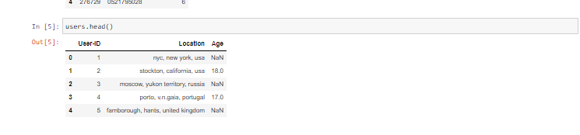

**Exploratory Data Analysis (EDA)**

**We performed a basic EDA to gain insights into the datasets:**

* **Checked for missing values in each dataset.**
* **Investigated the distribution of ratings and user demographics.**
* **Identified the top-rated books and their popularity.**

**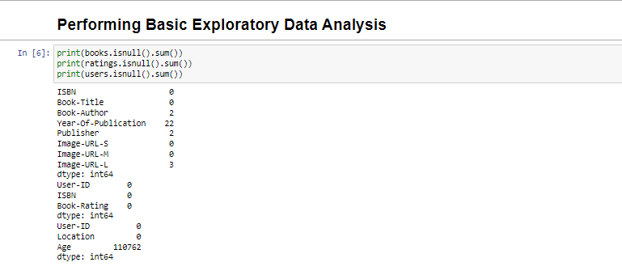  
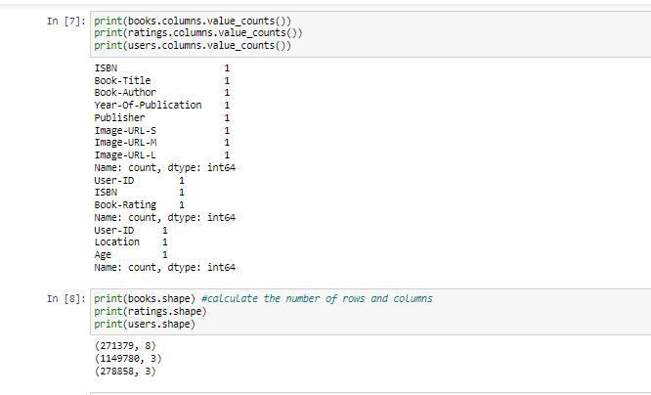**

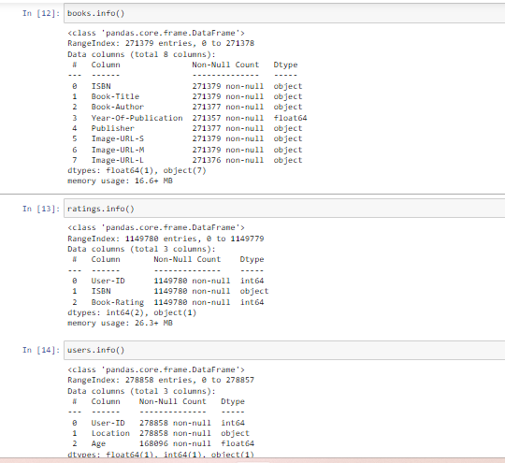

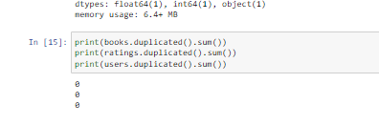

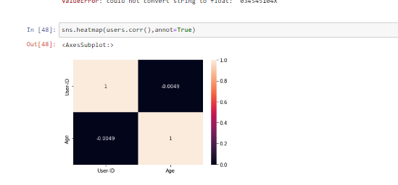

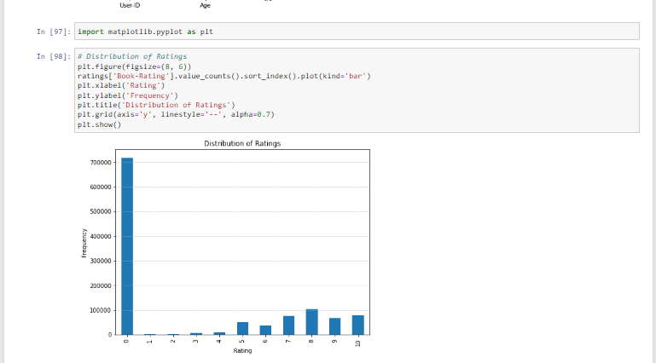

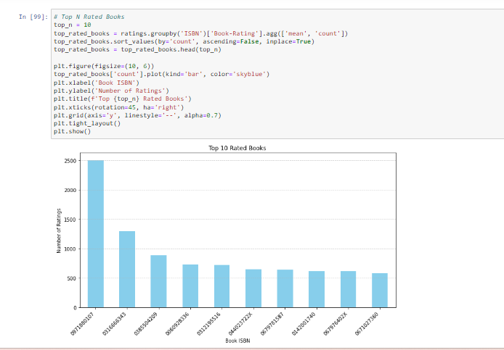

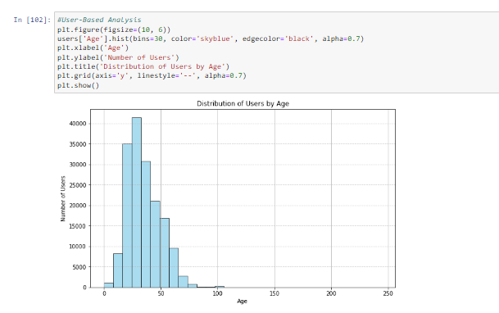

**Recommendation Systems**

**Popularity-Based Recommendation System:**

* **We aggregated ratings for each book and calculated the average rating.**
* **Filtered out books with fewer than 300 ratings to ensure reliability.**
* **Identified the top-rated books based on average rating and popularity.**

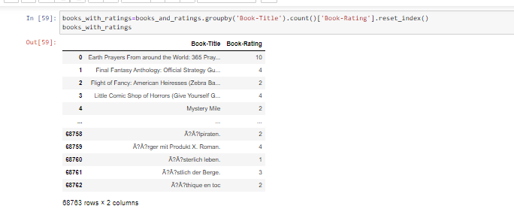

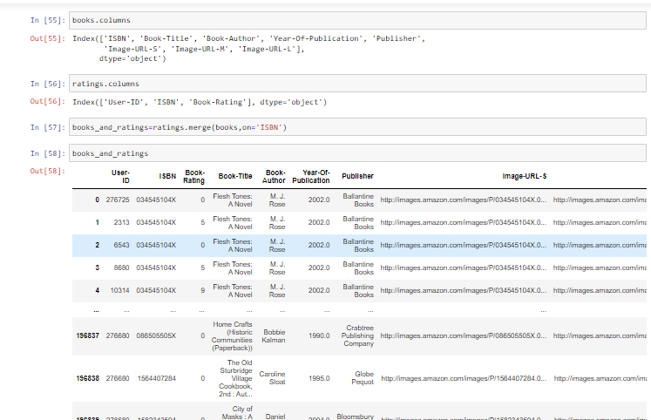

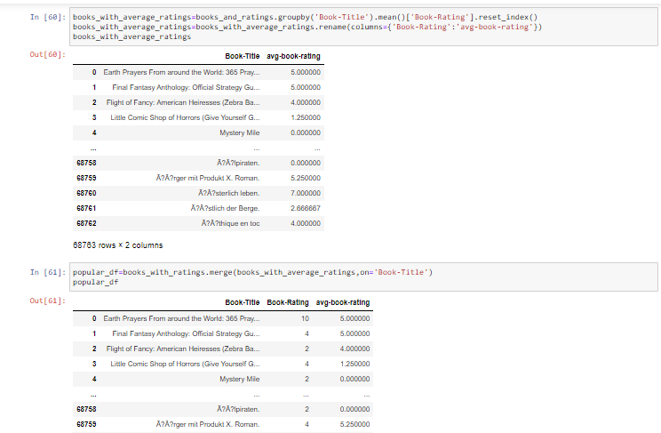

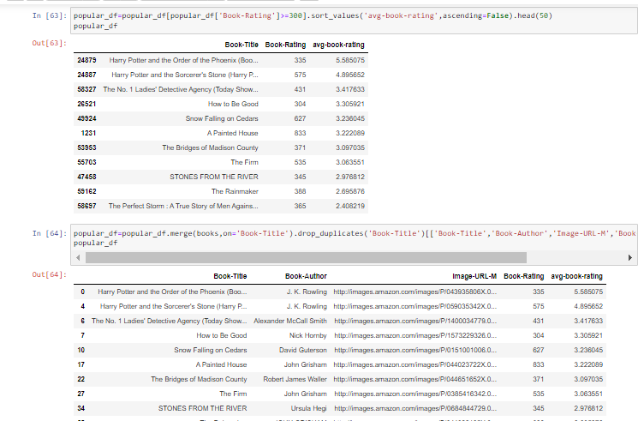



**Collaborative Filtering Based Recommendation System:**

* **Filtered users who have rated at least 300 books to ensure active users.**
* **Selected books with at least 50 ratings to ensure item reliability.**
* **Constructed a user-item matrix and computed similarity scores using cosine similarity.**
* **Developed a function to recommend similar books based on user preferences.**

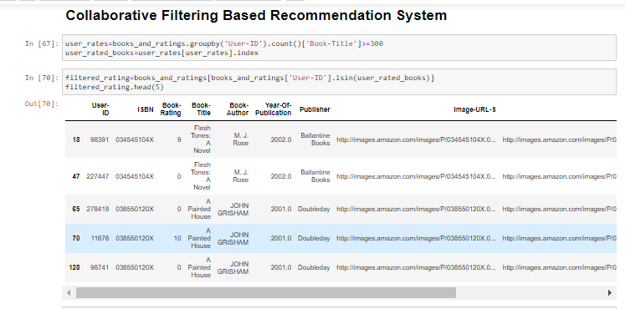

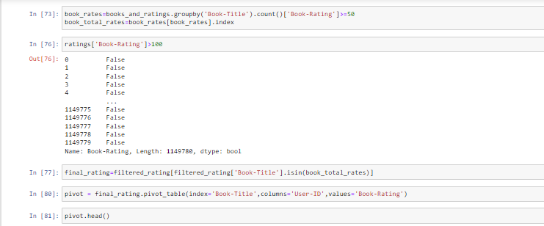

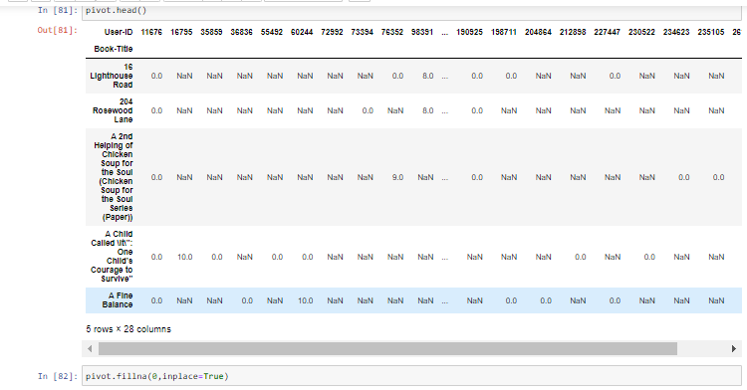

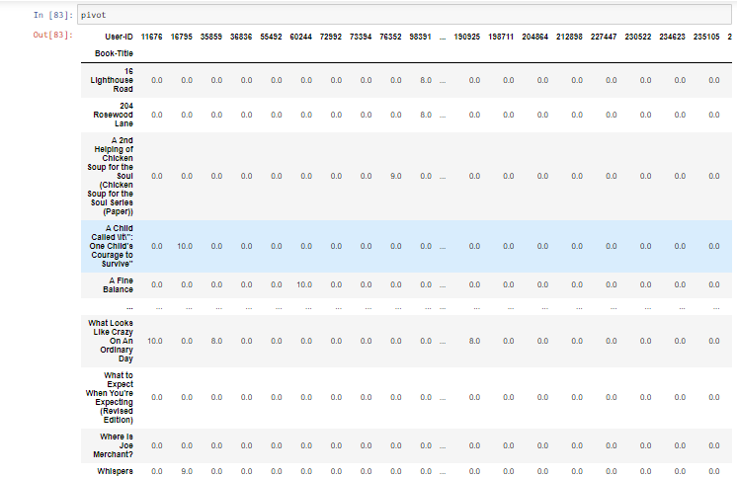

**Model Building**

**We utilized cosine similarity to measure the similarity between books and recommend similar items to users based on their preferences.**

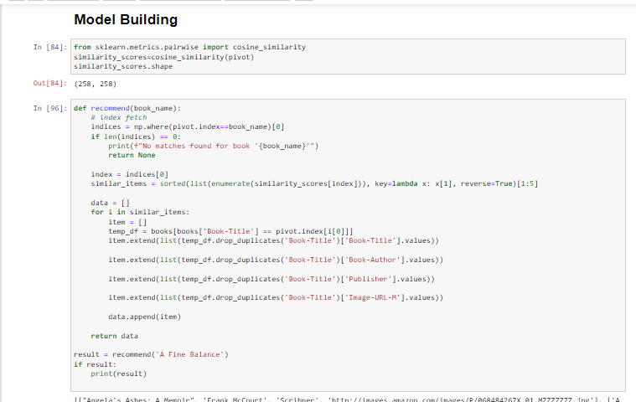

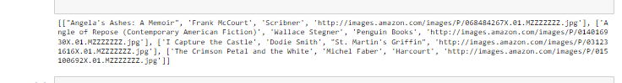

**Conclusion**

**In conclusion, we successfully developed a book recommendation system using collaborative filtering and popularity-based approaches. The system provides personalized recommendations to users based on their past interactions and preferences, enhancing their overall browsing and book selection experience.**

**Overall, this project demonstrates the effectiveness of recommendation systems in facilitating personalized content discovery and improving user engagement in online platforms.**

**This project lays the foundation for further enhancements and optimizations, such as incorporating more advanced algorithms and integrating real-time user feedback for continuous improvement.**